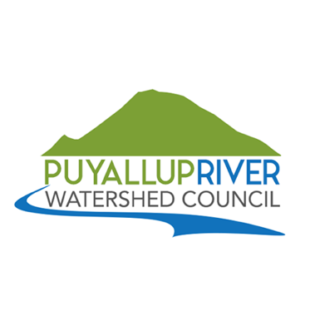

**Puyallup White River Local Integrating Organization (PWR-LIO)**

**LIO meeting**

September 10, 2020

3:00pm-5:00pm

Zoom

**AGENDA**

3:00pm **Welcome & Introductions** – Krystal Kyer, LIO Coordinator

* Name, affiliation, interests/expertise

3:10pm **Funding and Contracts Updates**– Tom Kantz, Pierce County

* 2021 LIO Capacity Funds - $125,000 – Scope of Work, RFP
* NTA selection and funding - $103,500 – Scope of Work

3:30pm **Recap ERP progress to date** – Elizabeth McManus and Mario Colon, Ross Strategic

**Review & Feedback on draft Ecosystem Recovery Plan Chapters:**

* Introduction
* Focus Areas chapters

4:50pm  **Timeline**

* Equity/Human well-being meeting: Sept.11
* Climate Change meeting: Sept.25
* Draft ERP submission: Sept.30
* NTA contracts in place for phases 2-3 of ERP development
* RFP published in September for LIO coordination
* LIO coordinator consultant under contract in October
* LIO Capacity Funds contract in effect: Oct.1, 2020 – Sept.30, 2021
* Quarterly LIO meeting: November 12
* 2021?

4:55pm **Roundtable/Announcements –** all

5:00pm **Adjourn**

Join Zoom Meeting

<https://zoom.us/j/369132092?pwd=TmRZeWpBdk9oQlFZRWNYSHIwUlNSZz09>

Meeting ID: 369 132 092

Password: 381872

One tap mobile

+16699009128,,369132092# US (San Jose)

+16465588656,,369132092# US (New York)

Dial by your location

        +1 669 900 9128 US (San Jose)

        +1 646 558 8656 US (New York)

Meeting ID: 369 132 092

Find your local number: <https://zoom.us/u/aqeodS3PL>